**Oracle SQL Sessions Assignment -2**

**1.**

select cont.continent,cntry.countryname

from continents cont

inner join countries cntry on cont.contid=cntry.continent

order by 1

**2.**

select cont.continent,count(cntry.countryname) as total_countries

from continents cont

inner join countries cntry on cont.contid=cntry.continent

group by cont.continent

order by 1

**3.**

select con.continent,cntry.countryname,cm.maker,cm.fullname

from continents con

inner join COUNTRIES cntry on con.contid=cntry.continent

left join car_makers cm on cntry.countryid=cm.country

where cm.country is null

order by 1;

**4.**

select cntry.countryname,cm.maker

from continents cont

inner join countries cntry on cont.contid=cntry.continent

inner join car_makers cm on cntry.countryid=cm.country

where cntry.countryname='japan'

**5.**

select cntry.countryname,cm.maker

from continents cont

inner join countries cntry on cont.contid=cntry.continent

inner join car_makers cm on cntry.countryid=cm.country

where cntry.countryname='france' or cntry.countryname='usa'

**6.**

select cont.continent,cntry.countryname,cm.maker,cm.fullname

from continents cont

inner join countries cntry on cont.contid=cntry.continent

inner join car_makers cm on cntry.countryid=cm.country

where cm.fullname='Volvo'

**7.**

select cm.fullname,md.model

from continents cont

inner join countries cntry on cont.contid=cntry.continent

inner join car_makers cm on cntry.countryid=cm.country

inner join MODEL_DETAILS md on cm.id=md.maker

where cm.fullname='Ford Motor Company'

**8.**

SELECT COUNT(md.model) AS total_count

FROM continents cont

INNER JOIN countries cntry ON cont.contid = cntry.continent

INNER JOIN car_makers cm ON cntry.countryid = cm.country

INNER JOIN MODEL_DETAILS md ON cm.id = md.maker

WHERE cntry.countryname = 'germany'

GROUP BY cntry.countryname

**9.**

SELECT cntry.countryname,md.model,cm.maker

FROM continents cont

INNER JOIN countries cntry ON cont.contid = cntry.continent

INNER JOIN car_makers cm ON cntry.countryid = cm.country

INNER JOIN MODEL_DETAILS md ON cm.id = md.maker

WHERE cntry.countryname = 'japan'

**10.a.**

**Maximum**

Select co.continent,cntry.countryname,cm.maker,cm.fullname,md.model,cn.descr,cd.mpg

from continents co

inner join countries cntry on co.contid = cntry.continent

inner join car_makers cm on cntry.countryid = cm.country

inner join model_details md on cm.id = md.maker

inner join car_names cn on md.model = cn.model

inner join car_details cd on cn.id = cd.id

where cd.mpg = (select max(mpg) from car_details)

**Minimum**

Select co.continent,cntry.countryname,cm.maker,cm.fullname,md.model,cn.descr,cd.mpg

from continents co

inner join countries cntry on co.contid = cntry.continent

inner join car_makers cm on cntry.countryid = cm.country

inner join model_details md on cm.id = md.maker

inner join car_names cn on md.model = cn.model

inner join car_details cd on cn.id = cd.id

where cd.mpg = (select max(mpg) from car_details)

**10.b**

**Maximum**

select co.continent,cntry.countryname,cm.maker,cm.fullname,md.model,cn.descr,cd.cylinders

from continents co

inner join countries cntry on co.contid = cntry.continent

inner join car_makers cm on cntry.countryid = cm.country

inner join model_details md on cm.id = md.maker

inner join car_names cn on md.model = cn.model

inner join car_details cd on cn.id = cd.id

where cd.cylinders = (select max(cylinders) from car_details)

**Minimum**

select co.continent,cntry.countryname,cm.maker,cm.fullname,md.model,cn.descr,cd.cylinders

from continents co

inner join countries cntry on co.contid = cntry.continent

inner join car_makers cm on cntry.countryid = cm.country

inner join model_details md on cm.id = md.maker

inner join car_names cn on md.model = cn.model

inner join car_details cd on cn.id = cd.id

where cd.cylinders = (select min(cylinders) from car_details)

**10.c**

**Maximum**

select co.continent,cntry.countryname,cm.maker,cm.fullname,md.model,cn.descr,cd.edispl

from continents co

inner join countries cntry on co.contid = cntry.continent

inner join car_makers cm on cntry.countryid = cm.country

inner join model_details md on cm.id = md.maker

inner join car_names cn on md.model = cn.model

inner join car_details cd on cn.id = cd.id

where cd.edispl = (select max(edispl) from car_details)

**Minimum**

select co.continent,cntry.countryname,cm.maker,cm.fullname,md.model,cn.descr,cd.edispl

from continents co

inner join countries cntry on co.contid = cntry.continent

inner join car_makers cm on cntry.countryid = cm.country

inner join model_details md on cm.id = md.maker

inner join car_names cn on md.model = cn.model

inner join car_details cd on cn.id = cd.id

where cd.edispl = (select min(edispl) from car_details)

**10.d**

**Maximum**

select co.continent,cntry.countryname,cm.maker,cm.fullname,md.model,cn.descr,cd.horsepower

from continents co

inner join countries cntry on co.contid = cntry.continent

inner join car_makers cm on cntry.countryid = cm.country

inner join model_details md on cm.id = md.maker

inner join car_names cn on md.model = cn.model

inner join car_details cd on cn.id = cd.id

where cd.horsepower = (select max(horsepower) from car_details)

**Minimum**

select co.continent,cntry.countryname,cm.maker,cm.fullname,md.model,cn.descr,cd.horsepower

from continents co

inner join countries cntry on co.contid = cntry.continent

inner join car_makers cm on cntry.countryid = cm.country

inner join model_details md on cm.id = md.maker

inner join car_names cn on md.model = cn.model

inner join car_details cd on cn.id = cd.id

where cd.horsepower = (select min(horsepower) from car_details)

**10.e**

**Maximum**

select co.continent,cntry.countryname,cm.maker,cm.fullname,md.model,cn.descr,cd.weight

from continents co

inner join countries cntry on co.contid = cntry.continent

inner join car_makers cm on cntry.countryid = cm.country

inner join model_details md on cm.id = md.maker

inner join car_names cn on md.model = cn.model

inner join car_details cd on cn.id = cd.id

where cd.weight = (select max(weight) from car_details)

**Minimum**

select co.continent,cntry.countryname,cm.maker,cm.fullname,md.model,cn.descr,cd.weight

from continents co

inner join countries cntry on co.contid = cntry.continent

inner join car_makers cm on cntry.countryid = cm.country

inner join model_details md on cm.id = md.maker

inner join car_names cn on md.model = cn.model

inner join car_details cd on cn.id = cd.id

where cd.weight = (select min(weight) from car_details)

**10.f.**

**Maximum**

select co.continent,cntry.countryname,cm.maker,cm.fullname,md.model,cn.descr,cd.accel

from continents co

inner join countries cntry on co.contid = cntry.continent

inner join car_makers cm on cntry.countryid = cm.country

inner join model_details md on cm.id = md.maker

inner join car_names cn on md.model = cn.model

inner join car_details cd on cn.id = cd.id

where cd.accel = (select max(accel) from car_details)

**Minimum**

select co.continent,cntry.countryname,cm.maker,cm.fullname,md.model,cn.descr,cd.accel

from continents co

inner join countries cntry on co.contid = cntry.continent

inner join car_makers cm on cntry.countryid = cm.country

inner join model_details md on cm.id = md.maker

inner join car_names cn on md.model = cn.model

inner join car_details cd on cn.id = cd.id

where cd.accel = (select min(accel) from car_details)

**11.**

select cd.year,count(cd.year) as total_count

from car_details cd

group by cd.year

order by 2 desc

fetch first 1 row only;

**12.**

select cd.year,count(cd.year) as total_count

from car_details cd

group by cd.year

order by 2 asc

fetch first 1 row only;

**13.a.**

select cd.year,min(cd.mpg),max(cd.mpg),avg(cd.mpg)

from car_details cd

group by cd.year

order by 1

**13.b.**

select cd.year,min(cd.cylinders),max(cd.cylinders),avg(cd.cylinders)

from car_details cd

group by cd.year

order by 1

**13.c.**

select cd.year,min(cd.edispl),max(cd.edispl),avg(cd.edispl)

from car_details cd

group by cd.year

order by 1

**13.d.**

select cd.year,min(cd.horsepower),max(cd.horsepower),avg(cd.horsepower)

from car_details cd

group by cd.year

order by 1

**13.e.**

select cd.year,min(cd.horsepower),max(cd.horsepower),avg(cd.horsepower)

from car_details cd

group by cd.year

order by 1

**13.f.**

select cd.year,min(cd.horsepower),max(cd.horsepower),avg(cd.horsepower)

from car_details cd

group by cd.year

order by 1

**14.1.**

select avg(cd.horsepower) as mean

from car_details cd

select median(cd.horsepower) as median

from car_details cd

select stddev(cd.horsepower) as standard_deviation

from car_details cd

**14.2.**

select avg(cd.weight) as mean

from car_details cd

select median(cd.weight) as median

from car_details cd

select stddev(cd.weight) as standard_deviation

from car_details cd

**14.3.**

select avg(cd.accel) as mean

from car_details cd;

select median(cd.accel) as median

from car_details cd;

select stddev(cd.accel) as standard_deviation

from car_details cd;

* By observing the values of mean,median and standard deviation in horsepower,we can say the median value is somewhat close to the mean value.so we conclude that all values in horsepower column are in similar range and these values are little bit away from the mean.
* By observing the values of mean,median and standard deviation in weight, we can say that the median value is little bit far from the mean value and these all values are lies far from the mean value.

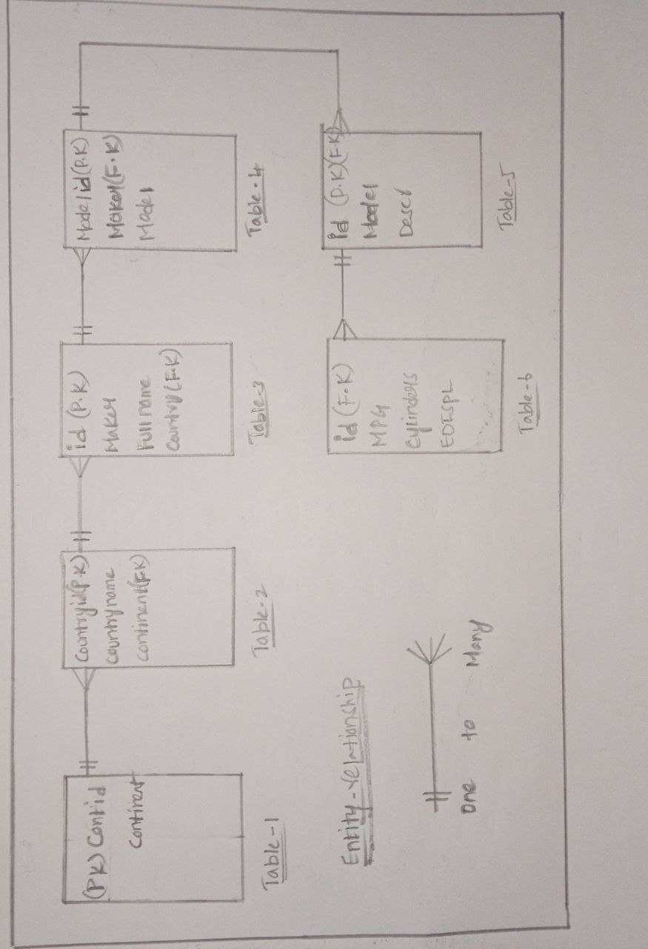

**15.**